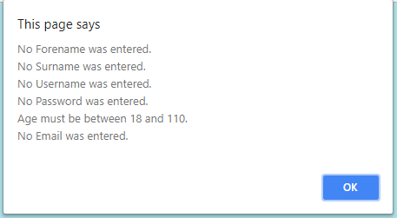





<!DOCTYPE html>

<html>

<head>

<script>

function setCookie(cname,cvalue,exdays) {

var d = new Date();

d.setTime(d.getTime() + (exdays\*24\*60\*60\*1000));

var expires = "expires=" + d.toGMTString();

document.cookie = cname + "=" + cvalue + ";" + expires + ";path=/";

}

function getCookie(cname) {

var name = cname + "=";

var decodedCookie = decodeURIComponent(document.cookie);

var ca = decodedCookie.split(';');

for(var i = 0; i < ca.length; i++) {

var c = ca[i];

while (c.charAt(0) == ' ') {

c = c.substring(1);

}

if (c.indexOf(name) == 0) {

return c.substring(name.length, c.length);

}

}

return "";

}

function checkCookie() {

var user=getCookie("username");

if (user != "") {

alert("Welcome again " + user);

} else {

user = prompt("Please enter your name:","");

if (user != "" && user != null) {

setCookie("username", user, 30);

}

}

}

</script>

</head>

<body onload="checkCookie()">

</body>

</html>

